Lecture: Applied Mathematics and Engineering

Speaker: Blair Cooper, Blackberry Co.

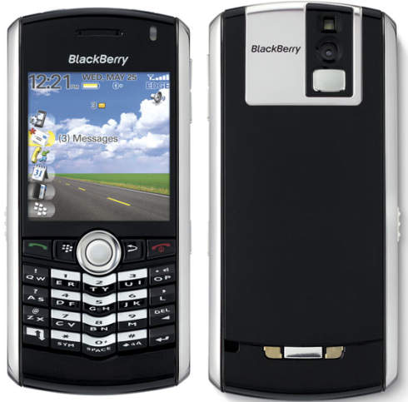
The workings and methods behind the latest technologies!

Monday, Mar. 9th in Portable 4, 2:30 – 4:00 P.M.

Hosted by SHS Math Club

