Warm-up (11/10/08)

Nonagon diagonals
In regular nonagon ABCDEFGHI, show that AF = AB + AC.
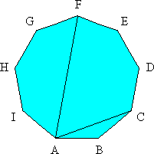

Solution
Draw line GC that intersects AF at point O. Then, GFO and ACO are similar, equilateral triangles (which can be shown by calculating the angles of the triangles). Thus, AC = AO and AB = GF = FO. Since AO + FO = AF, then AF = AB +AC.

