Warm-Up – SHS Math Club October 13, 2009

- (Without using calculus) Determine the slope (m) of the tangent line “y = mx + 2” to the parabola “y = x² + 5x + 6”.

- Let f be a real-valued function such that

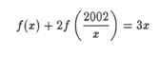

for all x > 0. Find f(2).

Problem Solving Method 3:

Change the problem to one you know how to deal with

Example: Determine the slope (m) of the tangent line “y = mx + 2” to the parabola “y = x² + 5x + 6”.

- What you might not know: Calculus
- What you do know: Algebra and Geometry

Normally, the derivative is used in this situation to find tangent slopes to a function, which is in this case a parabola. However, we can change the problem to one that is easier to deal with by simply observing the definition of a tangent line:

A tangent line intersects a function in only one spot

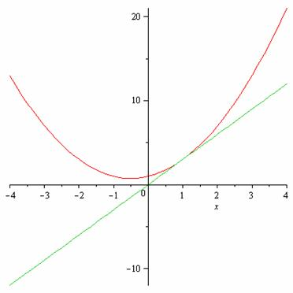

Thus, we can solve for the slope m by setting the equations y = mx + 2 and
y = x² + 5x + 6 equal to each other and giving m a value that makes the solution a complete square.

