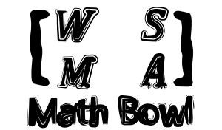 | WSMA Math Bowl – January 23, 2016  Creativity Round

1 | Put 6 X’s on a tic-tac-toe grid without 3 X’s in any direction, including the diagonals.
2 | If you list the first 20 numbers of the Fibonacci Sequence starting with two ones, then multiply the numbers, what is the hundreds digit of the resulting product?
3 | How many rotationally distinct ways are there to color the 6 sides of a regular hexagon either black or white?
4 | Suppose two people are playing a game. The game consists of an n number of sticks divided into 3 piles. Each turn, a player can take any number of sticks from a single pile. The players alternate turns, and the player who takes the last stick wins. If the size of heap A, B, and C consist of 3, 4, and 5 sticks respectively, then does the first player or the second player win or is it indeterminate? Prove your answer.
5 | Sudoku with a twist! (Ken-Ken) Your goal is to fill in the whole grid with numbers, making sure no number is repeated in any row or column. In this particular grid down below, use the numbers 1 - 5. The outlined areas are called “cages”. This puzzle has 10 cages. The top left corner of each cage has a “target number” and math operation (plus, minus, multiply, and divide). The numbers you enter into a cage must combine in any order to produce the target number using only the math operation at the top left. There cannot be more than one of each number in a cage. Use the grid provided on the answer sheet, and be aware that there may be more than one answer for the problem.

